Name: Anmol Srivastava
Roll no: 47
Section: A3

PRACTICAL 8

Aim: Implement Graph Colouring algorithm use Graph colouring concept.

Problem Statement:
A GSM is a cellular network with its entire geographical range divided into
hexadecimal cells. Each cell has a communication tower which connects with mobile
phones within cell. Assume this GSM network operates in different frequency
ranges. Allot frequencies to each cell such that no adjacent cells have same
frequency range.

Consider an undirected graph G = (V, E) shown in fig.
Find the colour assigned to each node using Backtracking method. Input is the adjacency matrix of a graph G(V, E), where V is the
number of Vertices and E is the number of edges.

CODE:

def graph_coloring(graph, max_colors):
n = len(graph)
solutions = set()
colors_assigned = [0] * n

def is_valid(vertex, color_choice):
for neighbor in range(n):
if graph[vertex][neighbor] == 1 and colors_assigned[neighbor] == color_choice:
return False
return True

def assign_colors(vertex):
if vertex == n:
solutions.add(tuple(colors_assigned))
return
for color in range(1, max_colors + 1):
if is_valid(vertex, color):
colors_assigned[vertex] = color
assign_colors(vertex + 1)
colors_assigned[vertex] = 0

assign_colors(0)
return solutions

graph_1 = [

[ 0, 1, 1, 0, 1],
[ 1, 0, 1, 1, 0],
[ 1, 1, 0, 1, 0],
[ 0, 1, 1, 0, 1],
[ 1, 0, 0, 1, 0]
]

max_colors = 3
solutions = graph_coloring(graph_1, max_colors)

print(" ".join(f"V{i+1}" for i in range(len(graph_1))))
for solution in solutions:
print(" ".join(f"C{c}" for c in solution))
print(f"Total Combinations: {len(solutions)}" if solutions else "Not Possible")

OUTPUT:
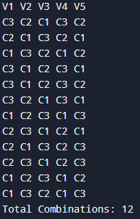

GeeksForGeeks:

